CS359 - Computer Network Lab
Lab 5
Tarusi Mittal 1901CS65
The folder contains two files:
1 server.c
2 client.c

1 Initially when we run the server and make one person join the server looks like this:
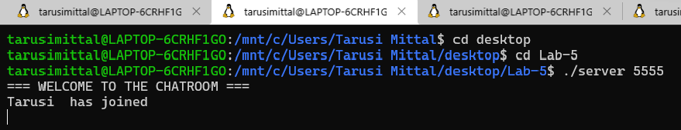

And the client side looks like this
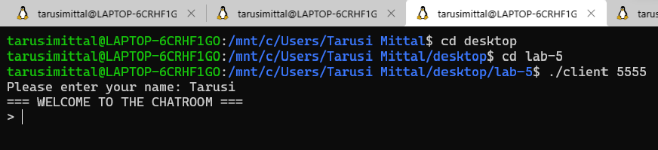

2. Then we join one another client
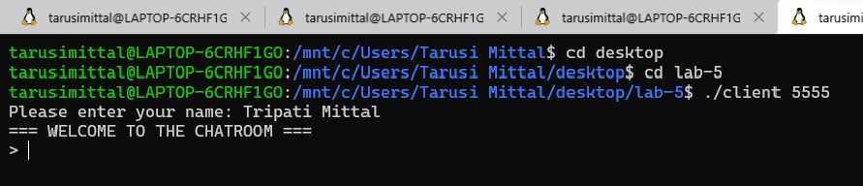

3. These are what our server and other client interfaces look then
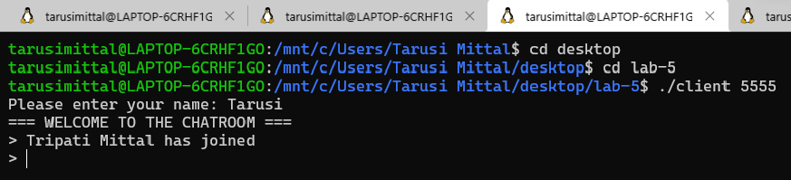
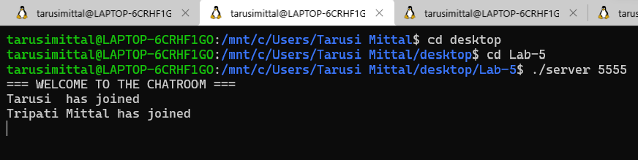

4. Then we make entry of our third client
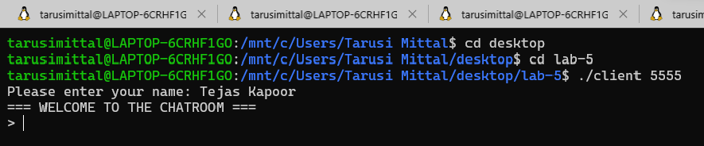

5. These are what our other client interfaces look then
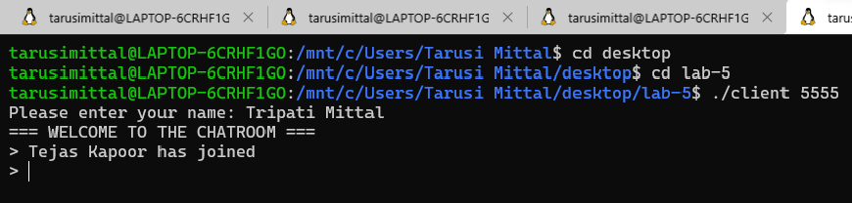’
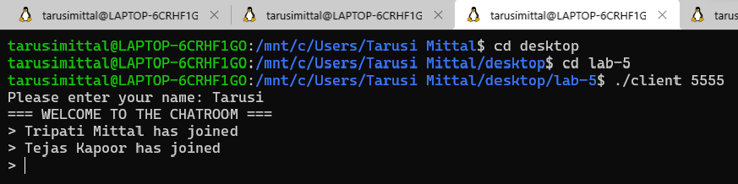
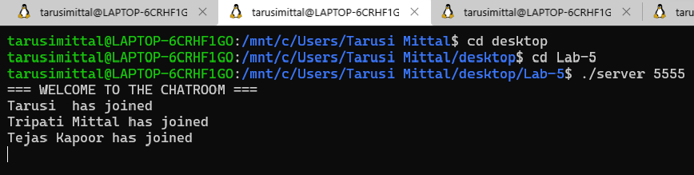

6. Now as two clients text these are hat client screens look now
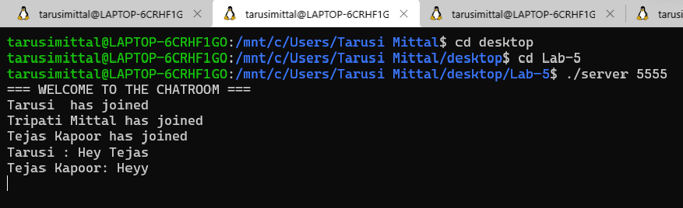
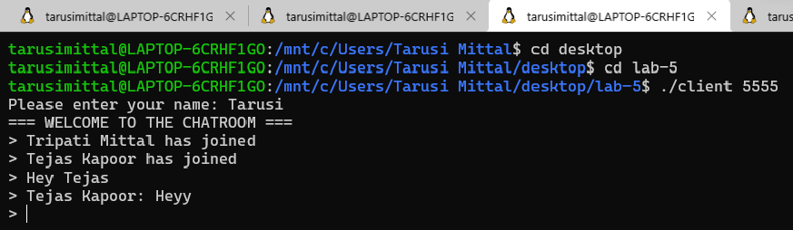
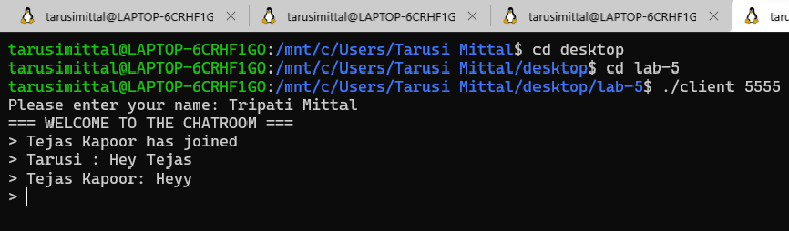
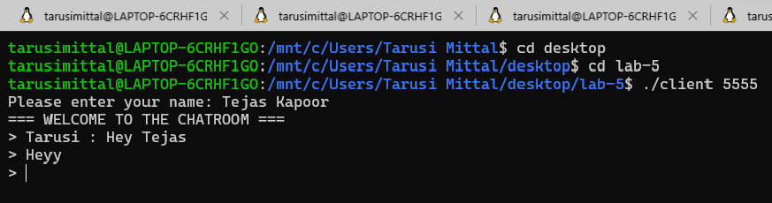

7. here are the screenshots of when our conversation is a little more
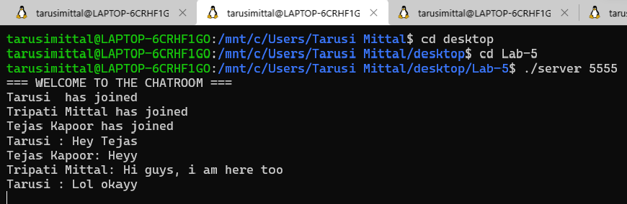
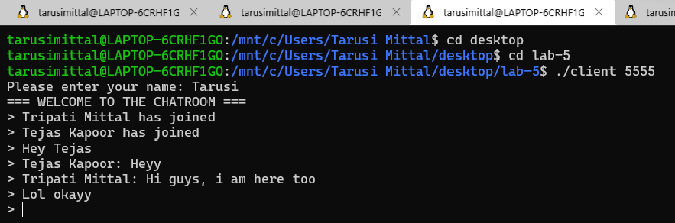
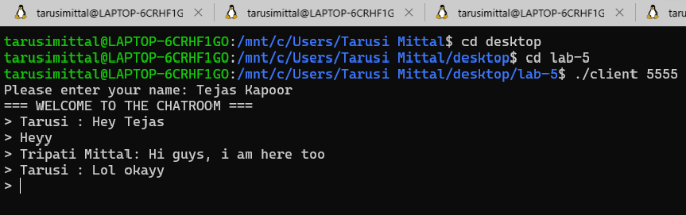

8. Now a new client has joined the chatbox
The client himself:
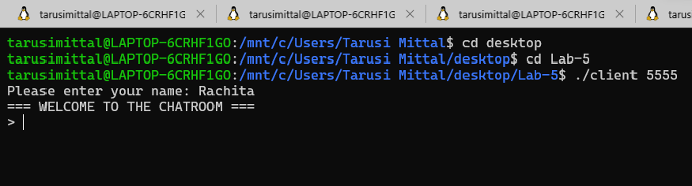

Other users:
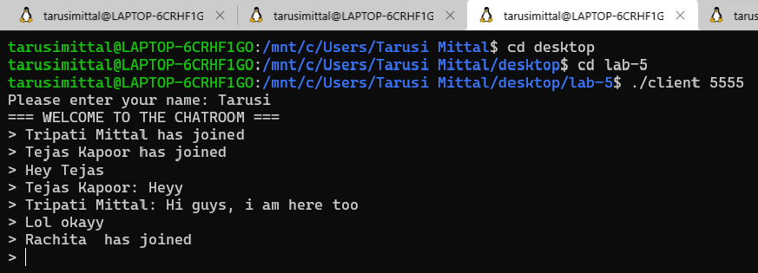

Server:
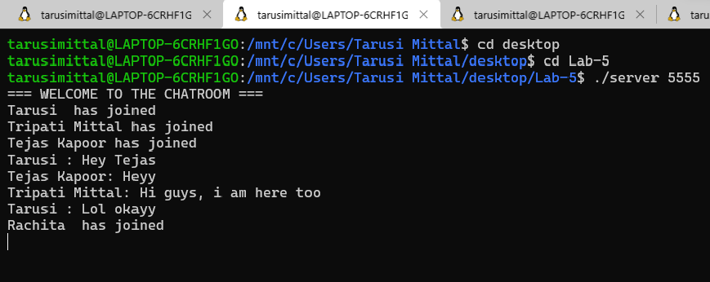

9. Now our new user texts and this are our interfaces
The user himself:
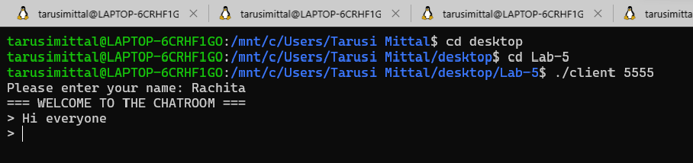

Other users:
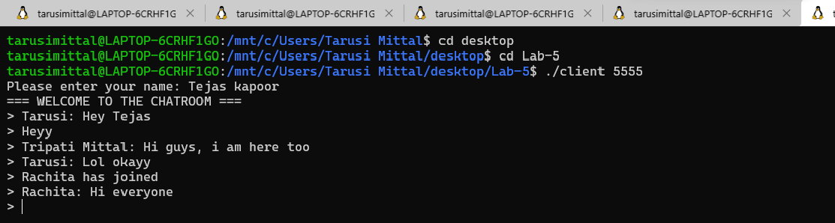

Server:
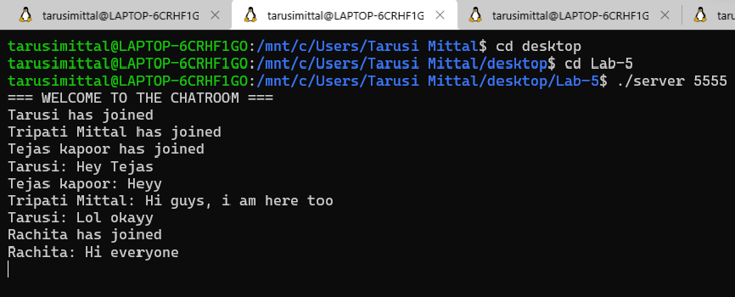

10. Now one of our user decides to leave the chatbox
Screen of user himself:
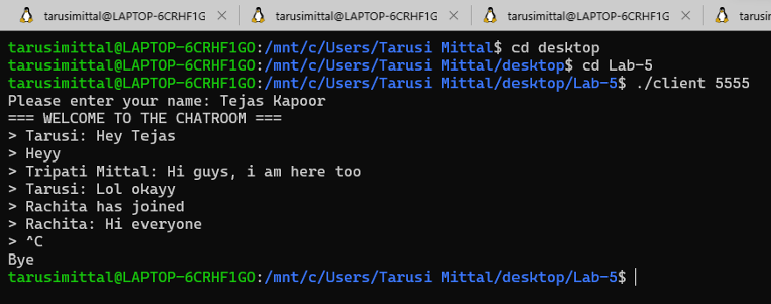

Server:
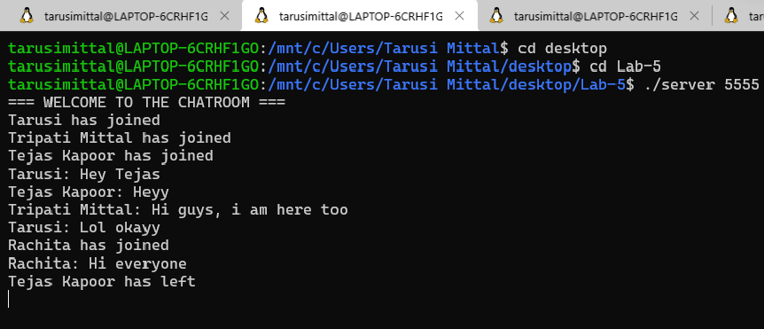

Other clients:
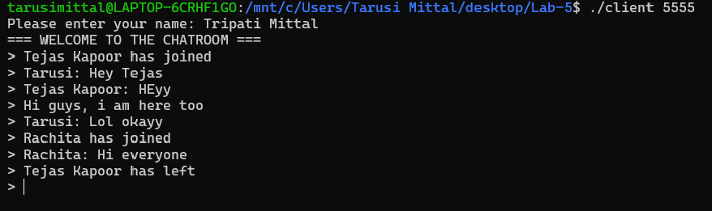

END

